Green Planet

Name: - H.W.H.R. De Silva

S Number: - S22009944

Registration Number: - 622511888

MS Teams Group Number: - WD01

Contents

Introduction 3

Problems 3

Air Pollution 4

Water Pollution 4

Soli Pollution 4

Solutions 5

3-R’s Principle 5

Architectural diagram 6

Used Web Technologies 7

HTML 7

CSS 7

JavaScript 7

VueJs 7

Screenshots of Website 8

Conclusion 13

References 14

# Introduction

Today, domestic waste management becomes a huge problem in society. Due to improper management of waste people face many problems like air pollution, water pollution and soil pollution. It causes many diseases. So it affects health in a very nasty way.

In order to prevent improper waste management I have created a website with green tips and solutions. It is consisted of five web pages.

* Home
* Issues
* Precautions
* 3-R’s principle
* Contact / Feedback

# Problems

Under this section, we are used to discuss about the problems which arise due to unmanaged waste disposal.

These problems can be categorized into three main sub problems. They are,

* Air pollution
* Water pollution
* Soil pollution

## Air Pollution

* People fire up garbage and poisonous smoke is added to the atmosphere.
* Photochemical smog can be happened.
* It reduces the visibility of air.
* The smell of garbage makes the air polluted.
* The smell of garbage is caused for spreading of flies.
* Diseases like Asthma, Lung cancers can be infected due to air pollution.

## Water Pollution

* Many living creatures in rivers and lakes die due to water pollution.
* People get infected with diseases like cholera, diarrhoea, dysentery, hepatitis A due to the usage of polluted water.
* Rubbish that is blocked in drains may cause to floods.
* Polluted water resources are birth places for mosquitoes.
* Therefore diseases like dengue, Chikungunya can be infected.

## Soli Pollution

* Useful animals lived in soil will be died due to firing up of garbage.

Ex:-Earth worm

* Ashes of fire make the structure of soil altered.
* Non-digesting garbage with toxic substances is adding chemicals to soil.
* Soil contamination affects metabolism of microorganisms in soil.

# Solutions

Here we are using 3-R concept for proper domestic garbage management.

# 3-R’s Principle

The principle of reducing waste, reusing and recycling resources and products is often called the "3Rs." Reducing means choosing to use things with care to reduce the amount of waste generated. Reusing involves the repeated use of items or parts of items which still have usable aspects. Recycling means the use of waste itself as resources. Waste minimization can be achieved in an efficient way by focusing primarily on the first of the 3Rs, "reduce," followed by "reuse" and then "recycle."

|  |  |
| --- | --- |
| Step | Example |
| Reduce | Minimizing the usage of polythine bags.  Using digital documents instead of using printouts and paper works.  Buying products with minimal packaging. |
| Reuse | Reuse organic garbage to make compost.  Using reusable shopping bags.  Repurposing glass jars and containers for storing food. |
| Recycle | Using bio degradable and recyclable packaging.  Recycling paper, plastic, glass, and metal containers through curbside recycling programs.  Handing over e-waste to recycle. |

*Table 1:- 3-R’s steps with corresponding examples*

# Architectural diagram

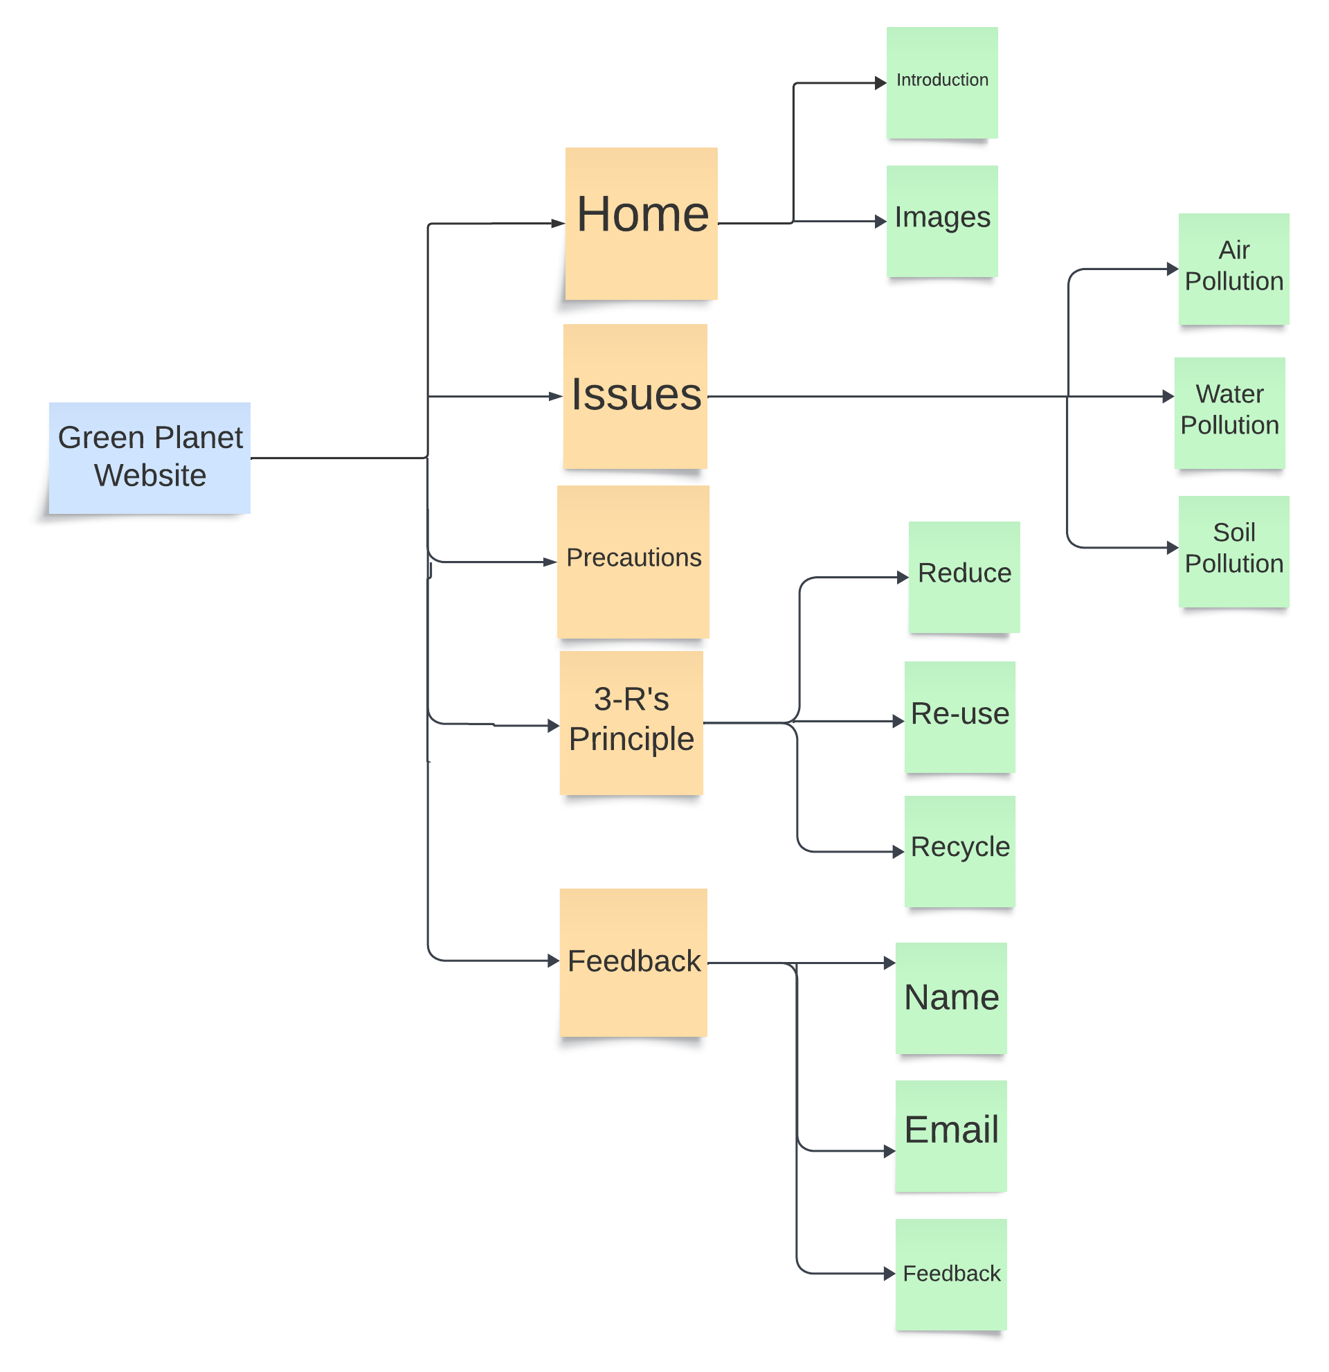

# Used Web Technologies

HTML

HTML is used to provide the backbone and structure of a web page. It defines the layout and organization of content on a web page by using a ranked structure of elements. HTML tags allow developers to specify the type of content being displayed and how it should be presented.

CSS

CSS is a language that helps developers style websites. It’s used to add design elements like colors, font styles, and spacing.

With CSS, the design is separate from the content, making it easier to change the design without affecting the content. Think of it like a set of instructions for your website, telling it how to look and feel.

JavaScript

JavaScript is a scripting language that enables you to create dynamically updating content, control multimedia, animate images, and pretty much everything else.

VueJs

Vue Js is a JavaScript framework for building user interfaces. It builds on top of standard HTML, CSS, and JavaScript and provides a declarative and component-based programming model that helps you efficiently develop user interfaces, be they simple or complex.

# Screenshots of Website

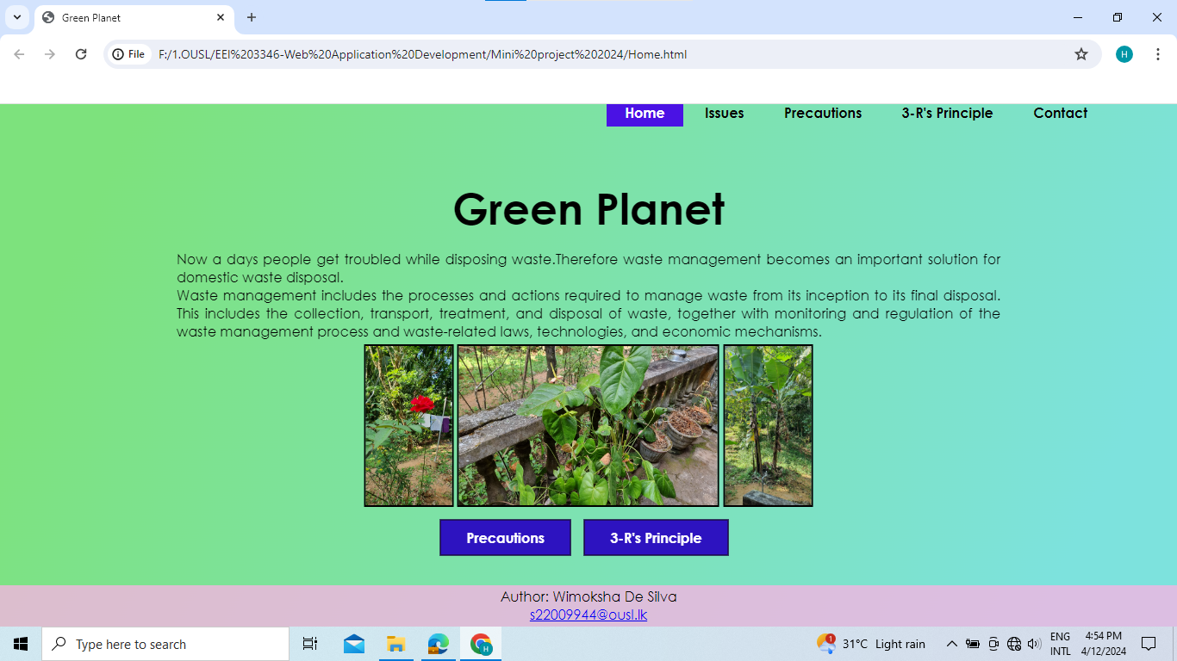

**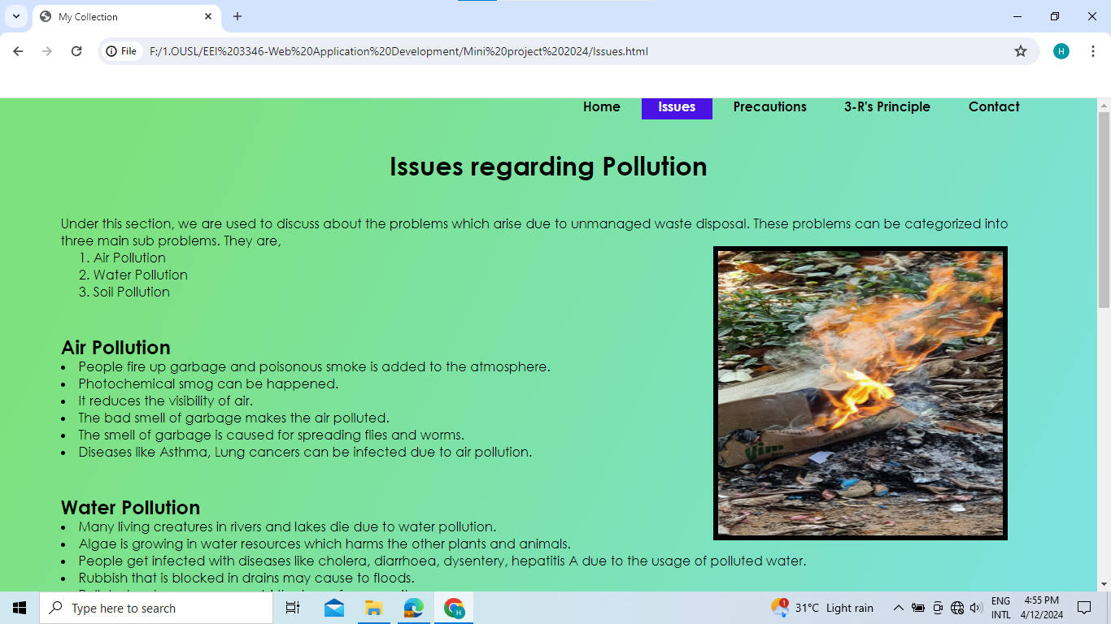*Figure 1****: Home webpage*

***Figure 2.1****: Issues webpage*

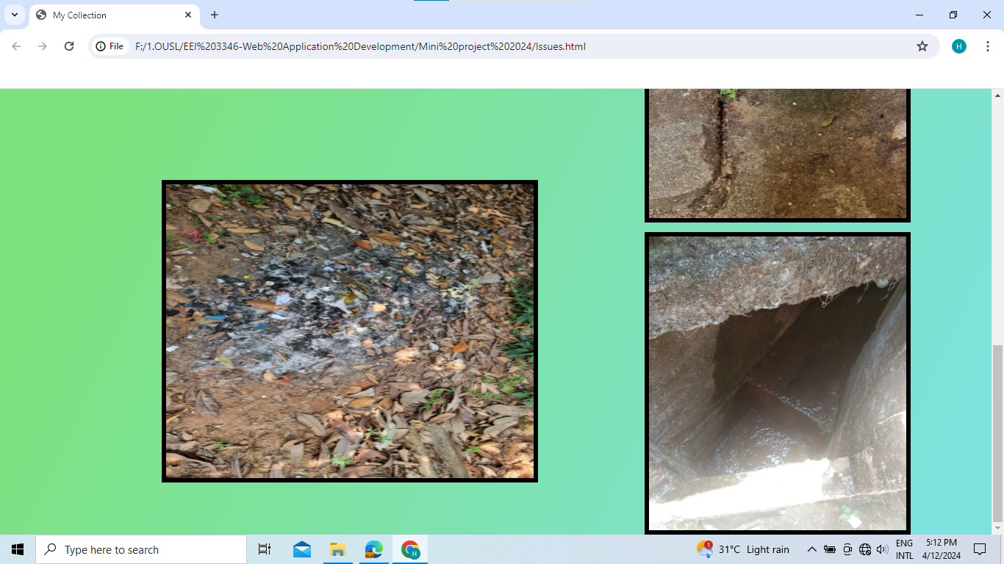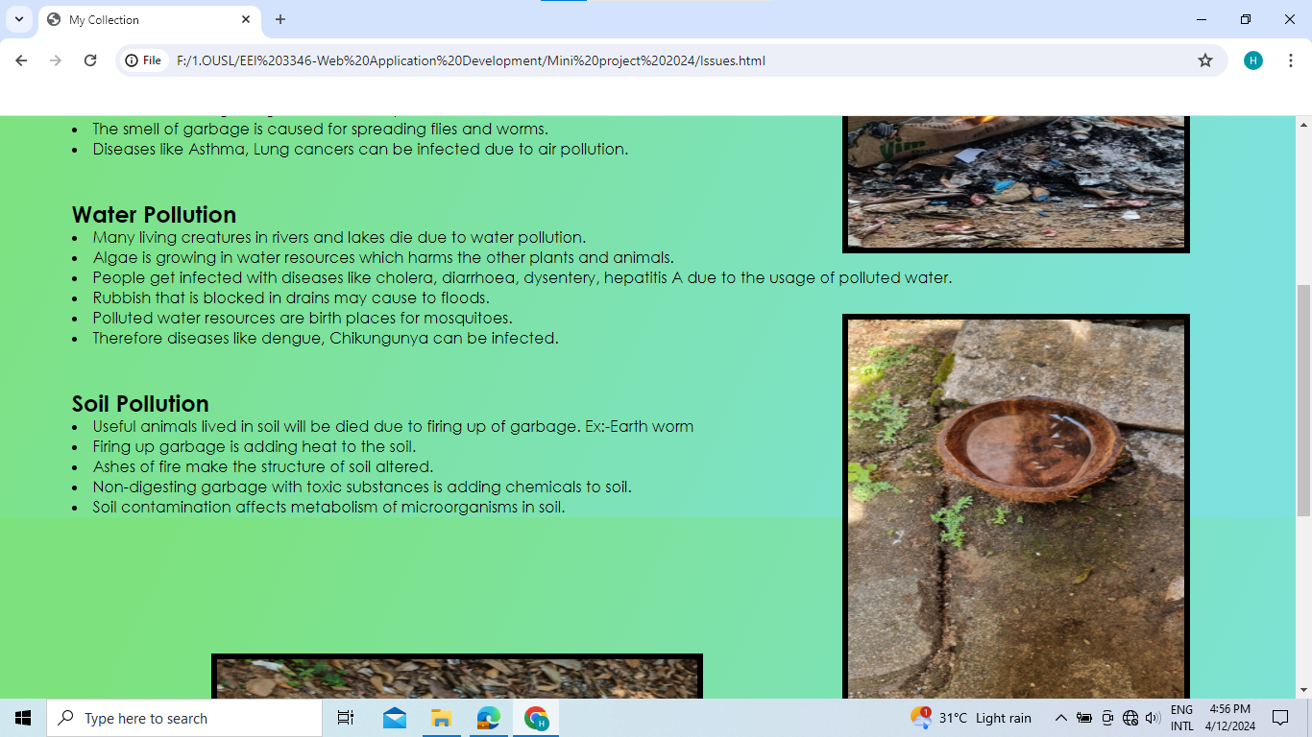

***Figure 2.2****: Issues webpage*

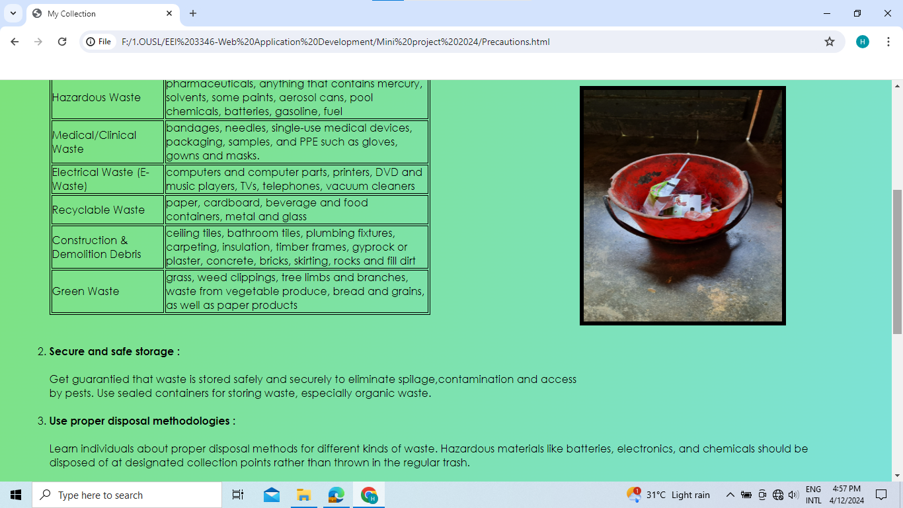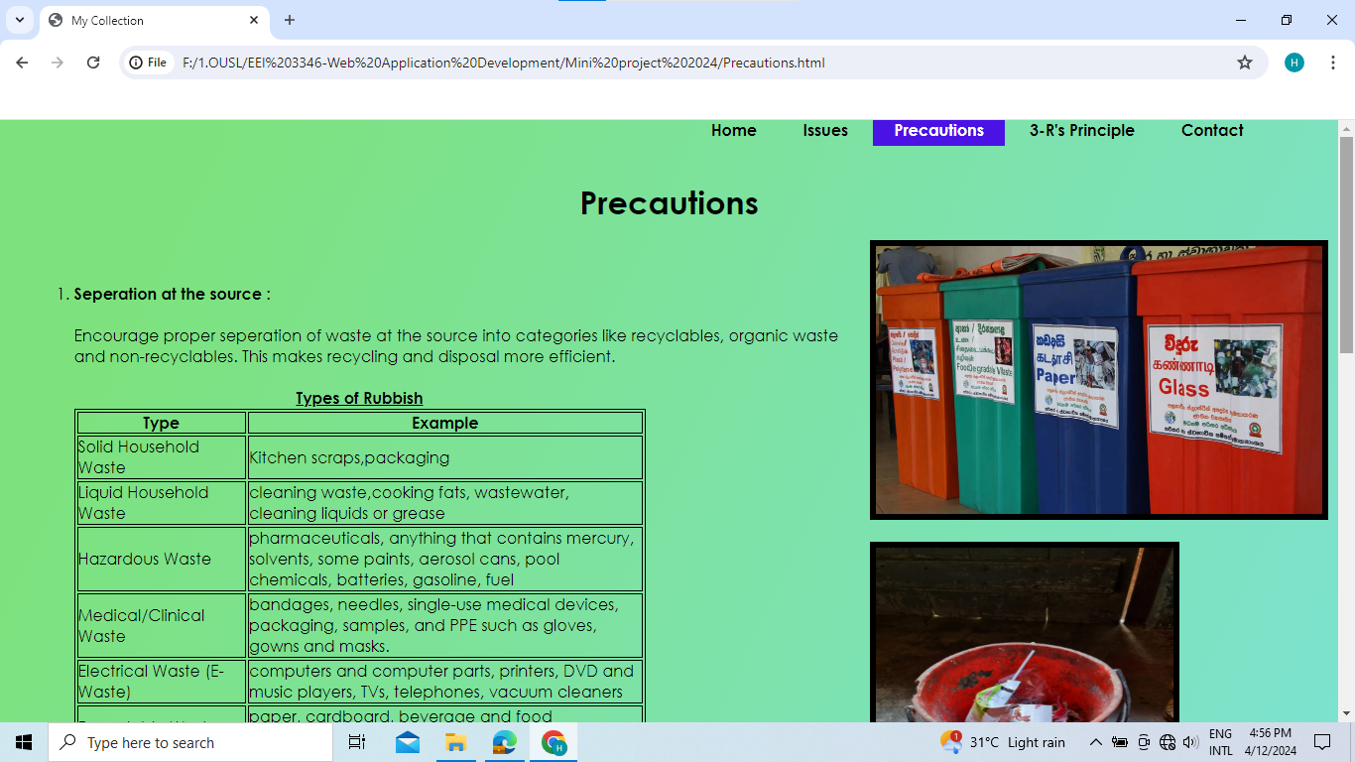

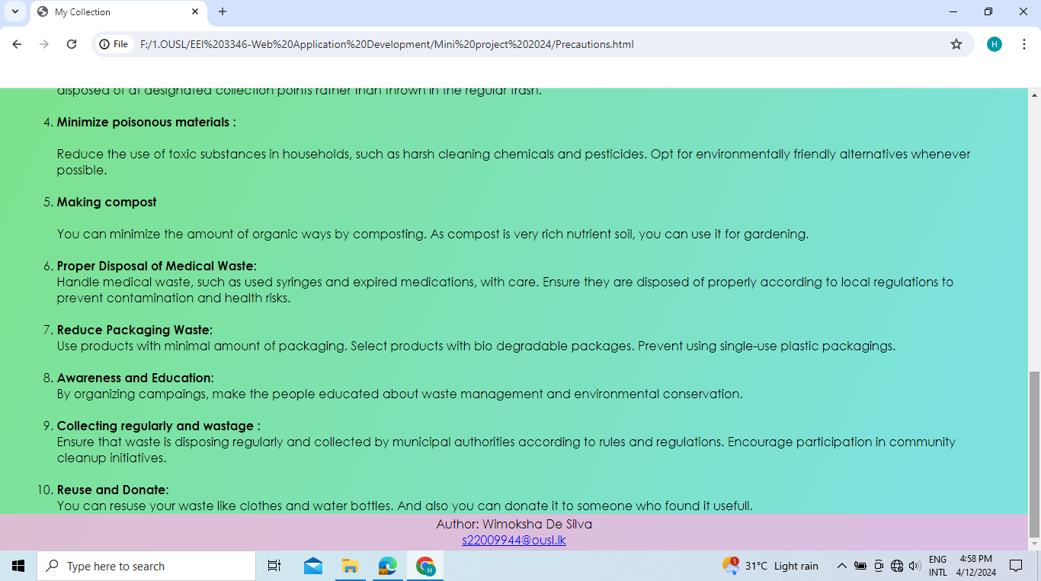

***Figure 3****: Precautions webpage*

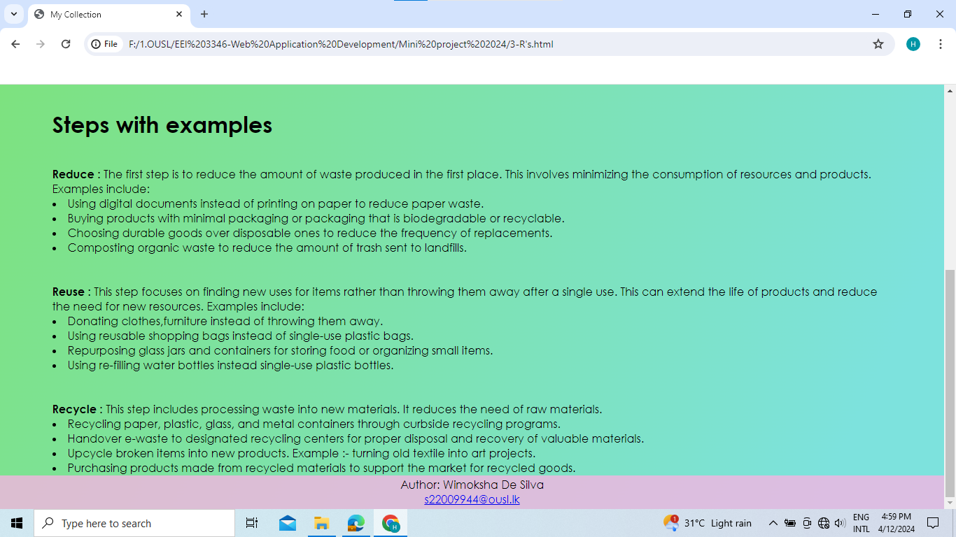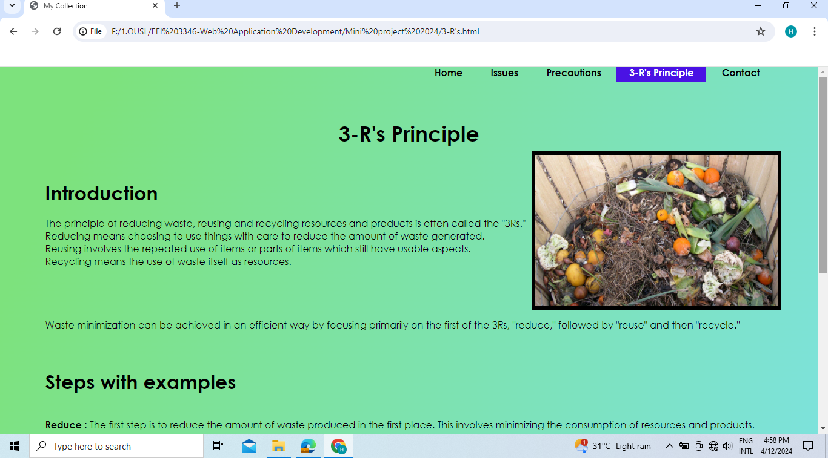

***Figure 4****: 3-R’s principle webpage*

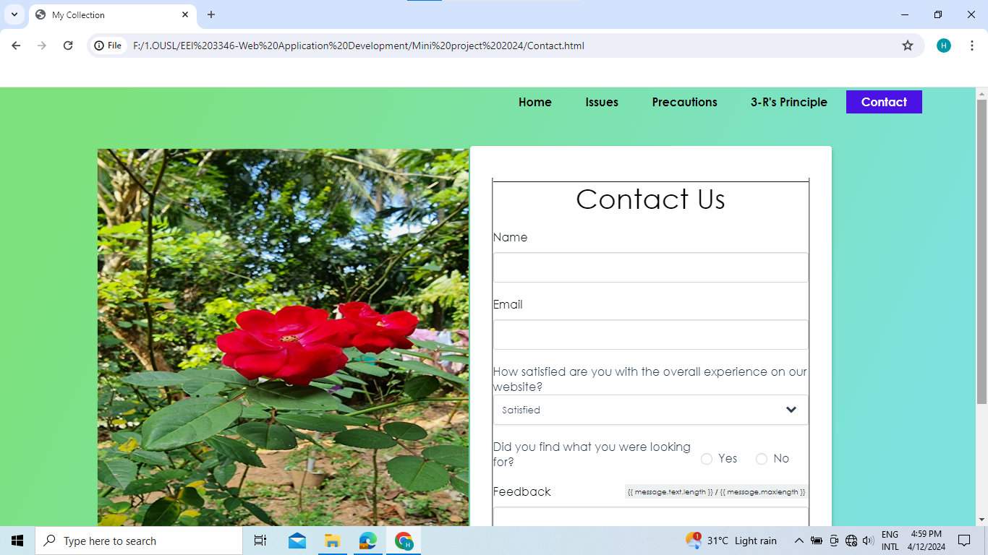

***Figure 5****: Contact webpage*

# Conclusion

I have created a website named as Green Planet with five different web pages under this mini project. It is consisted of so many green living tips. It enforces people to dispose their domestic waste efficiently without single harm to any living or non-living thing. This website is really beneficial for increasing greenery by recycling waste.

People who browse this website can get to know about 3-Rs Principal and how to dispose waste under the concept. They have the ability to minimize pollution.

Save things or waste, it’s your choice. We should not only go through the website, but also follow the steps and precautions to eliminate hazardous rubbish disposal. Let’s be a recycler, be a saver.

# References

Adams, P. M. (2003). Creating your own website.

Cambridge Dictionary. (n.d.). Cambridge Dictionary. Retrieved from Cambridge Dictionary: http://dictionary.cambridge.org/dictionary/british/clerk

Ducket, J. (2010). HTML and CSS . Design and Build Website, 27.

Ducket, J. (2010). Java Script and JQuery. Interactive Front End Development, 52,53.

Hoar, R. (2018). Fundamentals of Web Development . Pearson Education.

Morris, T. (2015). Basic of Web Designing . Pearson Education.